**Name: Mohammad Awais**

**Class: BSCS-8-A**

**CMS: 242554**

# Compiler Construction Lab 10

## Task 1:

### Code:

#### < task1_sloppy.cc >

#include <iostream>

using namespace std;

int main(){

cout<<"\nAverage of Power of Two Numbers Program\n\n";

int a,b;

int x = 1+1;

cout<<"Enter number A : ";

cin>>a;

int j = 12;

int o = 113;

int y = 23;

cout<<"Enter number B : ";

cin>>b;

a = a*(1+a)-a;

b = b*(1+b)-b;

int z = (a+b)/x;

cout<<"\nSum Z : "<<z<<endl;

return 0;

cout<<"I am part of code as well?";

}

#### < task1_optimized.cc >

#include <iostream>

using namespace std;

int main(){

cout<<"\nAverage Program\n\n";

int a,b;

int x = 2; *// CONSTANT FOLDING : EVALUATED*

cout<<"Enter number A : ";

cin>>a;

*// DEAD CODE : REMOVED*

cout<<"Enter number B : ";

cin>>b;

*// ALGEBRAIC SIMPLIFICATION*

a = a*a;

b = b*b;

int z = (a+b)/2; *// CONSTAMT PROPAGTION : SUBSTITUTED*

cout<<"\nSum Z : "<<z<<endl;

return 0;

*// UNREACHABLE CODE : REMOVED*

}

### Output:

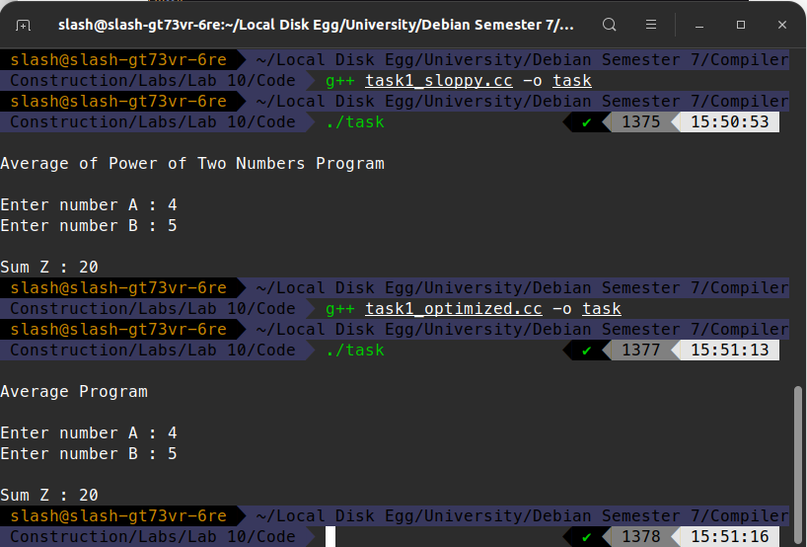

## Task 2:

### Code:

#### < task2.cc >

#include <iostream>

#include <fstream>

#include <string.h>

using namespace std;

int main(){

fstream my_file;

fstream new_file;

my_file.open("task1_sloppy.cc", ios::**in**);

new_file.open("task2_resultant.cc",ios::**out**);

if (!my_file) {

cout << "[-]File not found.!";

}

cout << "[+] File opened successfully!\n";

string line;

string new_line = "";

int mode = 0;

while(getline (my_file, line)){

for (int i=0; i<line.length(); i++){

if(mode==-2){

if(line[i]==';')

{

new_line+=';';

mode = -1;

}

}

else if (mode == -1){

if(line[i]=='}'){

mode=0;

}

}

else if(line[i] == '{' ){

mode =1;

}

else if(line.substr(i,6) == "return"&& mode ==1){

mode = -2;

new_line+="return";

i=i+5;

continue;

}

if(mode!=-1)

new_line+=line[i];

}

new_line+="\n";

}

new_file<<new_line;

my_file.close();

new_file.close();

cout<< "[+] New File Written successfully!\n";

}

### Screenshot:

#### < task1_sloppy.cc >

#include <iostream>

using namespace std;

int main(){

cout<<"\nAverage of Power of Two Numbers Program\n\n";

int a,b;

int x = 1+1;

cout<<"Enter number A : ";

cin>>a;

int j = 12;

int o = 113;

int y = 23;

cout<<"Enter number B : ";

cin>>b;

a = a*(1+a)-a;

b = b*(1+b)-b;

int z = (a+b)/x;

cout<<"\nSum Z : "<<z<<endl;

return 0;

cout<<"I am part of code as well?";

}

#### < CONSOLE OUTPUT>

#### 

#### < task2_resultant.cc >

#include <iostream>

using namespace std;

int main(){

cout<<"\nAverage of Power of Two Numbers Program\n\n";

int a,b;

int x = 1+1;

cout<<"Enter number A : ";

cin>>a;

int j = 12;

int o = 113;

int y = 23;

cout<<"Enter number B : ";

cin>>b;

a = a*(1+a)-a;

b = b*(1+b)-b;

int z = (a+b)/x;

cout<<"\nSum Z : "<<z<<endl;

return 0;

}